**Description:**

A balloon manufacturing company has its factories established at two locations in a state Location 1 and Location 2. Location 1 can produce up to 8500 packets of balloons and Location 2 can produce up to 4000 packets of balloons. The cost of producing 1 packet of balloons at Location 1 costs $80 and around $60 at Location 2. Now the packets of balloons must be delivered to 12 events happening in the state at different locations. The cost of delivering a packet of balloons from each factory to each event and the requirements of the event are given below. At most 1000 packets of balloons can be sent from a given factory to a given event. Determine how to minimize the cost of meeting all demands.

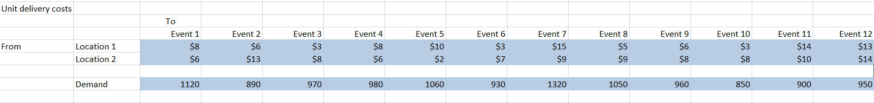

**Discussion:**

The objective of this problem is to minimize the cost. As per the given problem, cost is dependent on the delivery cost between a factory’s location and event and production cost of a unit of balloon by at each factory location. If we know the number of packets of balloons delivered from each location to each event, we will be able to calculate the total cost. Hence the decision variable will be the number of packets of balloons delivered from each location to each event.